Chapter 20
Financial Options
20-1. Explain the meanings of the following financial terms:
a. Option
b. Expiration date
c. Strike price
d. Call
e. Put
a. Option: An option is a contract that gives one party the right, but not the obligation, to buy or sell an asset at some point in the future.
b. Expiration date: The last date on which the holder still has the right to exercise the option. If the option is American, the right can be exercised until the exercise date; if it is European, the option can be exercised only on the exercise date.
c. Strike price: the price at which the holder of the option has the right to buy or sell the asset.
d. Call: An option that gives its holder the right to buy an asset.
e. Put: An option that gives its holder the right to sell an asset.
20-2. What is the difference between a European option and an American option? Are European options available exclusively in Europe and American options available exclusively in the United States?
European options can be exercised only on the exercise date, while American options can be exercised on any date prior to the exercise date. Both types of options are traded in both Europe and America.
20-3. Below is an option quote on IBM from the CBOE Web site showing options expiring in September and October 2012.
a. Which option contract had the most trades today?
b. Which option contract is being held the most overall?
c. Suppose you purchase one option with symbol IBM1222I210-E. How much will you need to pay your broker for the option (ignoring commissions)?
d. Explain why the last sale price is not always between the bid and ask prices.
e. Suppose you sell one option with symbol IBM1222I210-E. How much will you receive for the option (ignoring commissions)?
f. The calls with which strike prices are currently in-the-money? Which puts are in-the-money?
g. What is the difference between the option with symbol IBM1222I200-E and the option with symbol IBM1220J200-E?
h. On what date does the option with symbol IBM1222U200-E expire?
a. 12 Sep 200 Put
b. 12 Oct 205 call
c. $0.42 × 100 = $42
d. Last sale may have happened earlier in the day, whereas bid/ask are current quotes.
e. $0.36 × 100 = $36
f. Calls: 200, 205
Puts: 210, 215
g. Identical except that the second expires one month later than the first.
h. This expires the Saturday following the third Friday of September 2012, or September 22nd, 2012.
20-4. Explain the difference between a long position in a put and a short position in a call.
When a party has a long position in a put, it has the right to sell the underlying asset at the strike price; when it has a short position in a call, it has the obligation to sell the underlying asset at the strike price if exercised. These are clearly different positions.
20-5. Which of the following positions benefit if the stock price increases?
a. Long position in a call
b. Short position in a call
c. Long position in a put
d. Short position in a put
Long call and short put

20-6. You own a call option on Intuit stock with a strike price of $40. The option will expire in exactly three months’ time.
a. If the stock is trading at $55 in three months, what will be the payoff of the call?
b. If the stock is trading at $35 in three months, what will be the payoff of the call?
c. Draw a payoff diagram showing the value of the call at expiration as a function of the stock price at expiration.
Long call option: value at expiration:
a. $15
b. 0$
c. Draw graph:
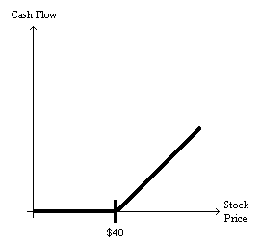
20-7. Assume that you have shorted the call option in Problem 6.
a. If the stock is trading at $55 in three months, what will you owe?
b. If the stock is trading at $35 in three months, what will you owe?
c. Draw a payoff diagram showing the amount you owe at expiration as a function of the stock price at expiration.
Short call: value at expiration date:
a. You owe $15.
b. You owe nothing.
c. Draw the payoff diagram:
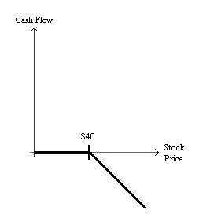
20-8. You own a put option on Ford stock with a strike price of $10. The option will expire in exactly six months’ time.
a. If the stock is trading at $8 in six months, what will be the payoff of the put?
b. If the stock is trading at $23 in six months, what will be the payoff of the put?
c. Draw a payoff diagram showing the value of the put at expiration as a function of the stock price at expiration.
Long put value at expiration:
a. $2
b. $0
c. Draw payoff diagram:
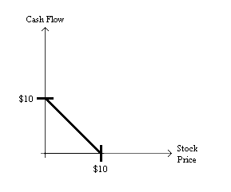
20-9. Assume that you have shorted the put option in Problem 8.
a. If the stock is trading at $8 in three months, what will you owe?
b. If the stock is trading at $23 in three months, what will you owe?
c. Draw a payoff diagram showing the amount you owe at expiration as a function of the stock price at expiration.
Short put: value at expiration:
a. You owe $2.  b. You owe nothing.  c. Draw payoff diagram: | 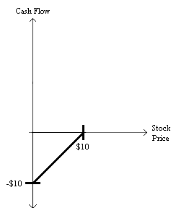
20-10. What position has more downside exposure: a short position in a call or a short position in a put? That is, in the worst case, in which of these two positions would your losses be greater?
Downside exposure is larger with a short call (the downside is unlimited) than with a short put (the downside cannot be larger than the strike price).
20-11. Consider the September 2012 IBM call and put options in Problem 3. Ignoring any interest you might earn over the remaining few days’ life of the options:
a. Compute the break-even IBM stock price for each option (i.e., the stock price at which your total profit from buying and then exercising the option would be zero).
b. Which call option is most likely to have a return of −100%?
c. If IBM’s stock price is $216 on the expiration day, which option will have the highest return?
a. For calls, strike + ask. For puts, strike – ask.
b. 215 call option is worthless if IBM is below 215.
c. 210 call option has return of 6/.42 – 1 = 1,329%.
20-12. You are long both a call and a put on the same share of stock with the same exercise date. The exercise price of the call is $40 and the exercise price of the put is $45. Plot the value of this combination as a function of the stock price on the exercise date.
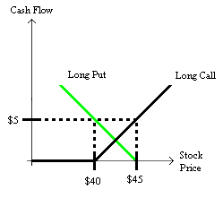
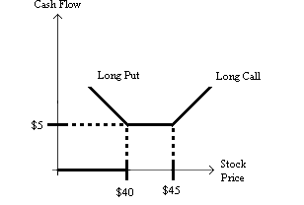
20-13. You are long two calls on the same share of stock with the same exercise date. The exercise price of the first call is $40 and the exercise price of the second call is $60. In addition, you are short two otherwise identical calls, both with an exercise price of $50. Plot the value of this combination as a function of the stock price on the exercise date. What is the name of this combination of options?
The top curve is the $40 Call, the middle curve is the $60 Call, the bottom curve is the short position in two $50 calls and the up then down curve is the combination.
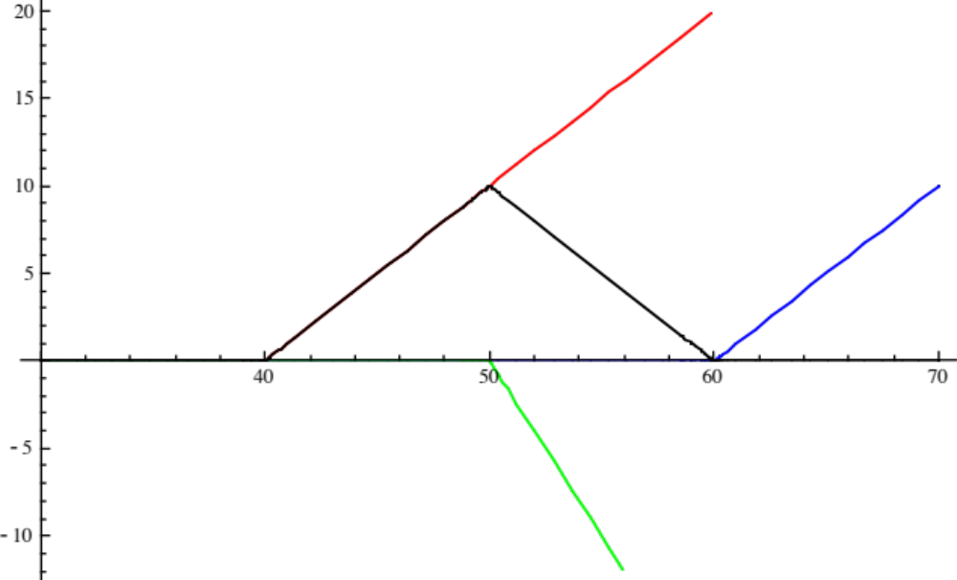
$40 Call

Combination
$60 Call

Short position

This is called a Butterfly Spread.
20-14. A forward contract is a contract to purchase an asset at a fixed price on a particular date in the future. Both parties are obligated to fulfill the contract. Explain how to construct a forward contract on a share of stock from a position in options.
A forward with price p can be constructed by longing a call and shorting a put with strike p.
20-15. You own a share of Costco stock. You are worried that its price will fall and would like to insure yourself against this possibility. How can you purchase insurance against this possibility?
To protect against a fall in the price of Costco, you can buy a put with Costco as the underlying asset. By doing this, over the life of the option you are guaranteed to get at least the strike price from selling the stock you already have.
20-16. It is September 13, 2012, and you own IBM stock. You would like to insure that the value of your holdings will not fall significantly. Using the data in Problem 3, and expressing your answer in terms of a percentage of the current value of your portfolio:
a. What will it cost to insure that the value of your holdings will not fall below $200 per share between now and the third Friday in September?
b. What will it cost to insure that the value of your holdings will not fall below $200 per share between now and the third Friday in October?
c. What will it cost to insure that the value of your holdings will not fall below $205 per share between now and the third Friday in October?
a. To ensure that the value of your IBM does not fall significantly, you would purchase a protective put. The current ask price for a protective put with a strike price of $200 that expires the third Friday of September is $0.22 per share. As a percentage of your portfolio this cost to insure is $0.22/$206.36 = .0011 or 0.11% of the value of your portfolio.
b. The ask price of a protective put with a strike price of $200 that expires on the third Friday of October is $2.05. The cost to insure the value of your holdings will not fall is $2.05/$206.36 = 0.0099 or 0.99%.
c. The ask price of a protective put with a strike price of $205 that expires on the third Friday of October is $3.65. The cost to insure the value of your holdings will not fall is $3.65/$206.36 = 0.0177 or 1.77%.
20-17. Dynamic Energy Systems stock is currently trading for $33 per share. The stock pays no dividends. A one-year European put option on Dynamic with a strike price of $35 is currently trading for $2.10. If the risk-free interest rate is 10% per year, what is the price of a one-year European call option on Dynamic with a strike price of $35?
Put-call parity:
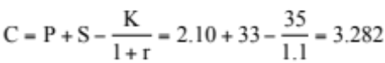
20-18. You happen to be checking the newspaper and notice an arbitrage opportunity. The current stock price of Intrawest is $20 per share and the one-year risk-free interest rate is 8%. A one year put on Intrawest with a strike price of $18 sells for $3.33, while the identical call sells for $7. Explain what you must do to exploit this arbitrage opportunity.
The arbitrage opportunity exists because:
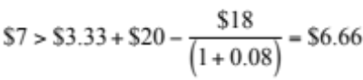.
So the call is overpriced compared to the portfolio of a put, the stock, and risk-free borrowing.
As a result, the strategy would be to sell the call option, buy the put, buy the stock, and borrow $16.67 (the present value of $18).
The net amount left after doing this is $.34, with no cash flows when the options expire.
20-19. Consider the September 2012 IBM call and put options in Problem 3. Ignoring the negligible interest you might earn on T-Bills over the remaining few days’ life of the options, show that there is no arbitrage opportunity using put-call parity for the options with a $100 strike price. Specifically:
a. What is your profit/loss if you buy a call and T-Bills, and sell IBM stock and a put option?
b. What is your profit/loss if you buy IBM stock and a put option, and sell a call and T-Bills?
c. Explain why your answers to (a) and (b) are not both zero.
a. Consider: Buy call and T-Bills, sell stock & put –2.49 – 205 + 205.29 + 1.03 = –1.17
b. Sell call and T-Bills, buy stock & put +2.36 +205 – 206.30 – 1.10 = –0.04
c. Both are negative due to transactions costs: call spread (0.13) + put spread (0.07) + stock spread (1.01) = 1.21 in total loss in (a) & (b)
20-20. Suppose Amazon stock is trading for $70 per share, and Amazon pays no dividends.
a. What is the maximum possible price of a call option on Amazon?
b. What is the maximum possible price of a put option on Amazon with a strike price of $100?
c. What is the minimum possible value of a call option on Amazon stock with a strike price of $50?
d. What is the minimum possible value of an American put option on Amazon stock with a strike price of $100?
a. $70 (Stock price)
b. $100 (strike price)
c. Intrinsic value = $20
d. Intrinsic value = $30
20-21. Consider the data for IBM options in Problem 3. Suppose a new American-style put option on IBM is issued with a strike price of $215 and an expiration date of October 1st.
a. What is the maximum possible price for this option?
b. What is the minimum possible price for this option?
a. No one will pay more than the price of the October option (which expires later), so $9.75.
b. No one would sell for less than the sale price of the September option: $8.60.
20-22. You are watching the option quotes for your favorite stock, when suddenly there is a news announcement. Explain what type of news would lead to the following effects:
a. Call prices increase, and put prices fall.
b. Call prices fall, and put prices increase.
c. Both call and put prices increase.
a. Good news about the stock, which raises its stock price
b. Bad news, which lowers the stock’s price
c. News that increases the volatility of the stock
20-23. Explain why an American call option on a non-dividend-paying stock always has the same price as its European counterpart.
Because the option to exercise early is worthless, the American option provides no more benefits than its European counterpart.
20-24. Consider an American put option on XAL stock with a strike price of $55 and one year to expiration. Assume XAL pays no dividends, XAL is currently trading for $10 per share, and the one-year interest rate is 10%. If it is optimal to exercise this option early:
a. What is the price of a one-year American put option on XAL stock with a strike price of $60 per share?
b. What is the maximum price of a one-year American call option on XAL stock with a strike price of $55 per share?
a. It is optimal to exercise early puts with higher strikes, so value = intrinsic value of 60 – 10 = $50.
b. Because the put has no time value, call value must be less than dis(55) = 55 – 55/1.10 = $5.
20-25. The stock of Harford Inc. is about to pay a $0.30 dividend. It will pay no more dividends for the next month. Consider call options that expire in one month. If the interest rate is 6% APR (monthly compounding), what is the maximum strike price where it could be possible that early exercise of the call option is optimal? (Round to the nearest dollar.)
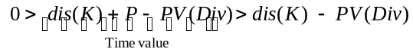
so
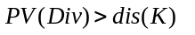
i.e., the discount on strike must be smaller than dividend. Given 6%/12 = 0.5% interest over the month,
K – K/1.005 < 0.30
so
K < 0.30 × 1.005/0.005 = $60.30.
So, strikes at or below $60 per share could be exercised early.
20-26. Suppose the S&P 500 is at 900, and a one-year European call option with a strike price of $400 has a negative time value. If the interest rate is 5%, what can you conclude about the dividend yield of the S&P 500? (Assume all dividends are paid at the end of the year.)
Call has negative time value implies
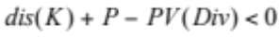
which means that
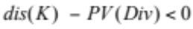
or PV(div) > dis(K), or FV(divs) > interest on K = 5% × 400 = 20. So dividend yield must be at least 20/900 = 2.22%.
20-27. Suppose the S&P 500 is at 900, and it will pay a dividend of $30 at the end of the year. Suppose also that the interest rate is 2%. If a one-year European put option has a negative time value, what is the lowest possible strike price it could have?
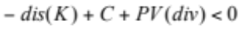
implies that
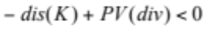
or
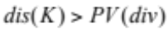
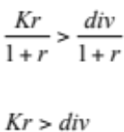
so interest on strike must exceed the dividend: (.02 × K) > $30, so K > 1500.
20-28. Wesley Corp. stock is trading for $25/share. Wesley has 20 million shares outstanding and a market debt-equity ratio of 0.5. Wesley’s debt is zero-coupon debt with a 5-year maturity and a yield to maturity of 10%.
a. Describe Wesley’s equity as a call option. What is the maturity of the call option? What is the market value of the asset underlying this call option? What is the strike price of this call option?
b. Describe Wesley’s debt using a call option.
c. Describe Wesley’s debt using a put option.
a. Maturity = 5 years
Assets = E + D = $25 per share × 20 million shares + .5($25 × 20) = $500 + 250 = $750 million
The market value of the asset underlying this call option is $750.00 million.
The strike price is equal to the debt. Therefore,
The strike price of this call option is $402.63 million.
b. Long the firm’s assets and short the equity call option above
c. Long risk-free debt and short a put option on Wesley’s assets with a 5-yr maturity and $402.63 million face value
20-29. Express the position of an equity holder in terms of put options.
An equity holder is long a put on a share of the value of the firm assets with the per-share value of debt as the strike price, long a share on the assets of the firm and short a loan worth the value per share of the debt.
20-30. Use the option data from July 13, 2009 in the following figure to determine the rate Google would have paid if it had issued $128 billion in zero-coupon debt due in January 2011. Suppose Google currently had 320 million shares outstanding, implying a market value of $135.1 billion. (Assume perfect capital markets.)
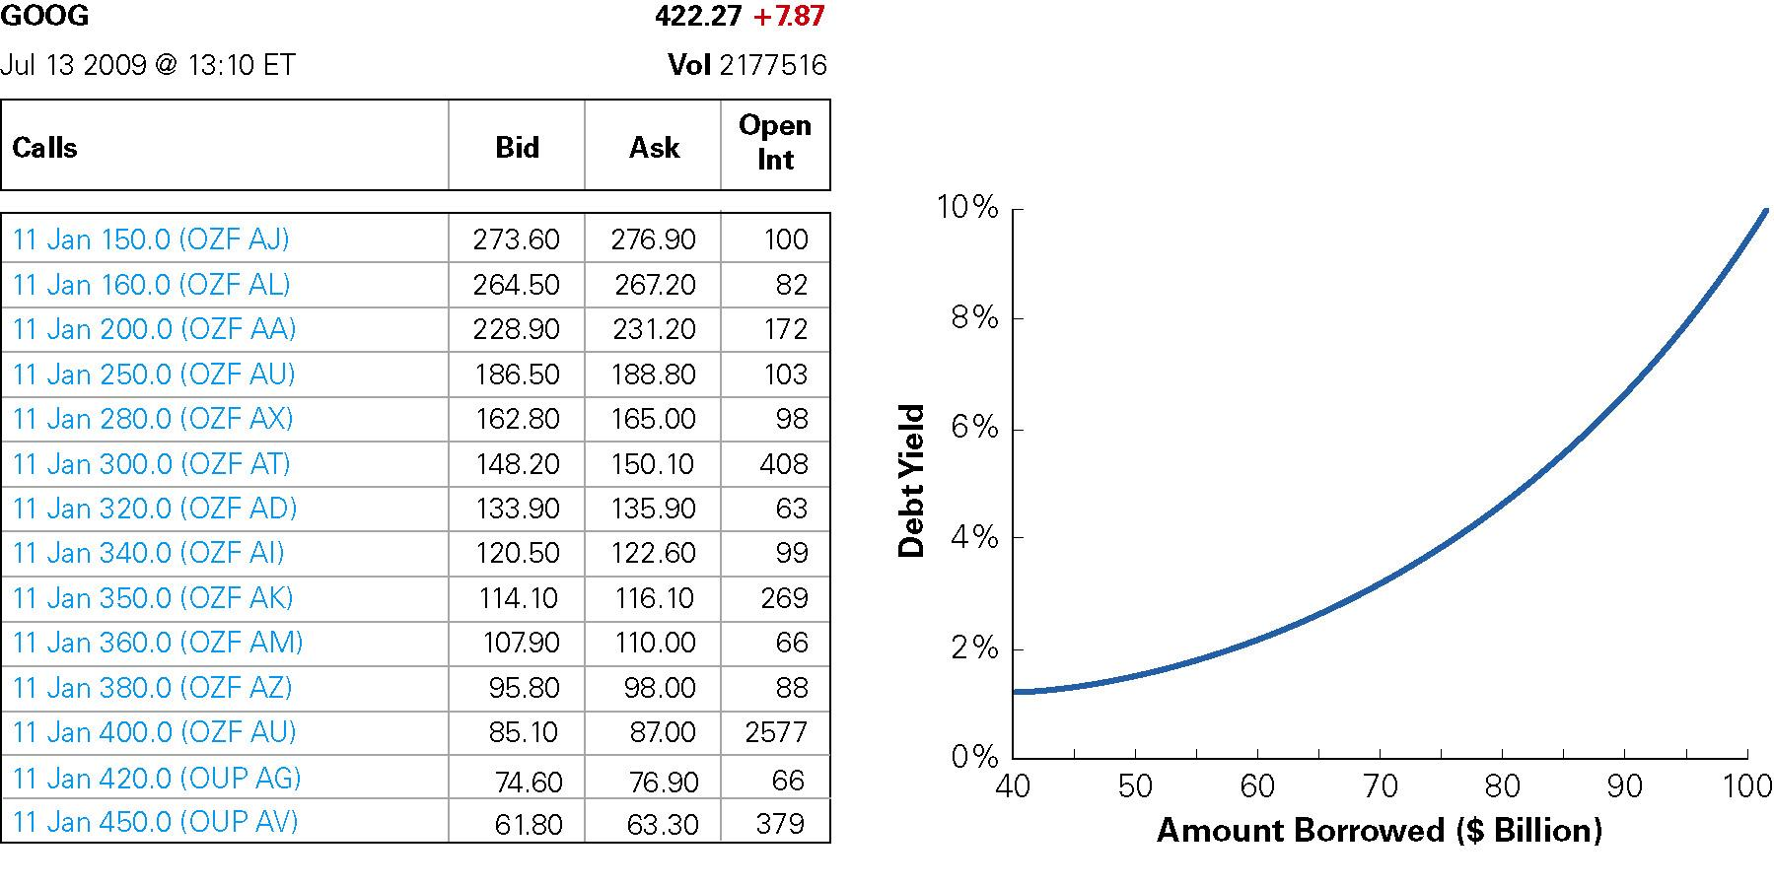
Issuing $128 billion in debt is equivalent to a claim on $400 of Google’s assets per share. From Table 20.5, the average of the bid-ask spread of the 11 Jan 400 Call is $86.05. This gives a market value of the remaining equity of 86.05 × 320 = $27.54 billion. Subtracting from the total value of $135.1 billion gives the estimated value of the debt: 135.1 – 27.54 = 107.56 billion. The yield to maturity is then 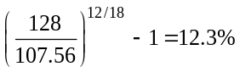. The credit spread is therefore 12.3% – 1% = 11.1 %.
20-31. Suppose that in July 2009, Google were to issue $96 billion in zero-coupon senior debt, and another $32 billion in zero-coupon junior debt, both due in January 2011. Use the option data above to determine the rate Google would pay on the junior debt issue. (Assume perfect capital markets.)
We can compute the rate on the senior debt as in Example 20.10. The debt value is $87.4 billion, and the rate is 6.46%.
Next, we can determine the value of equity. Because the firm has $96 + 32 = $128 billion in total debt, or 128b/320m = $400 per share, from Figure 20.10, the average of the bid-ask spread of the 11 Jan 400 Call is $86.05. This gives a market value of the remaining equity of 86.05 × 320 = $27.54 billion.
Because Senior Debt + Junior Debt + Equity must equal the total value of $135.1 billion,
Junior debt has a value of 135.1 – 87.4 – 27.54 = $20.16 billion.
Therefore, the yield on the junior debt is
